**BUILDING THE CI/CD FREESTYLE PIPELINE USING JENKINS FOR MAVEN JAVA PROJECT**

Create a freestyle project and click ok

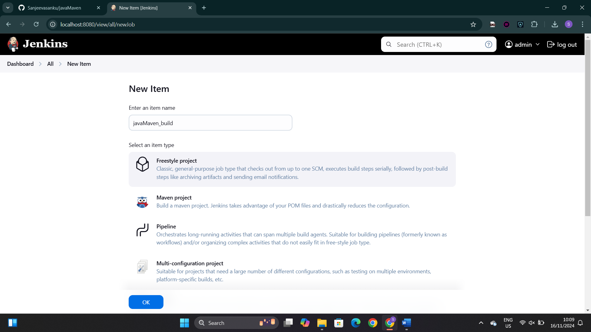

Copy the url of the git repository

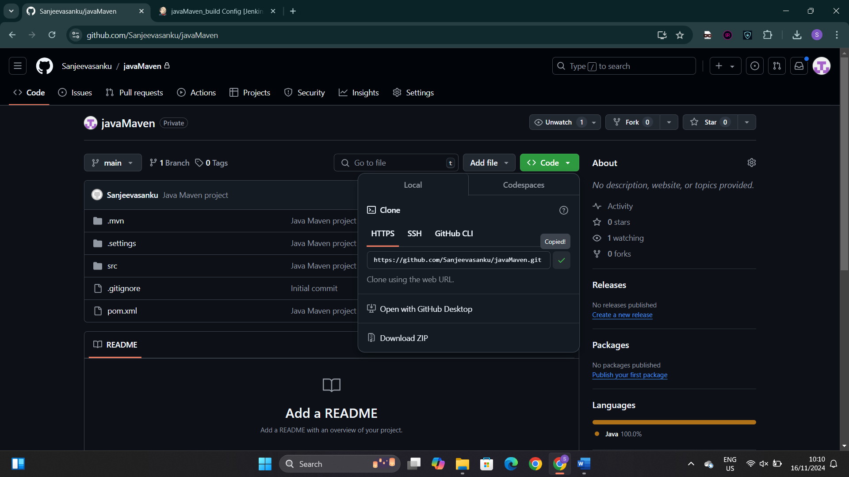

Paste the git url in this section

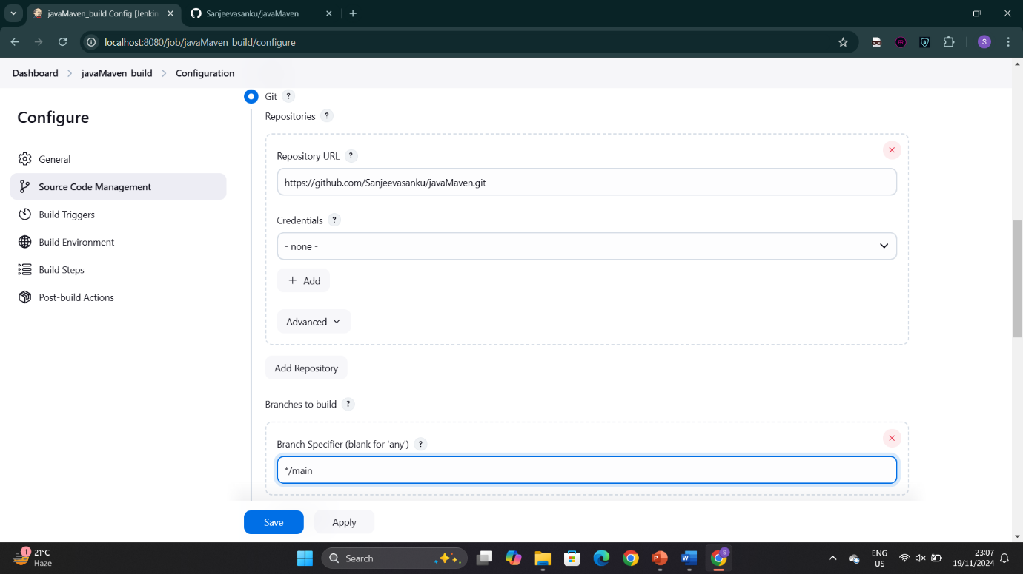

Select invoke top-level Maven targets in build step

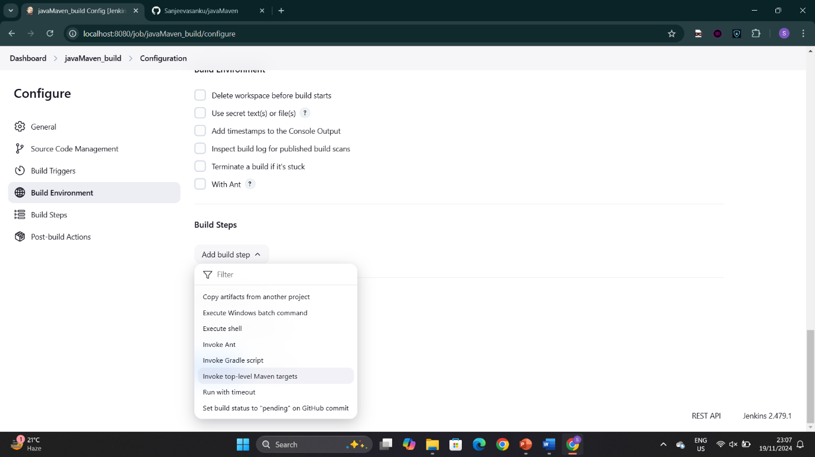

Set the goals as clean and install

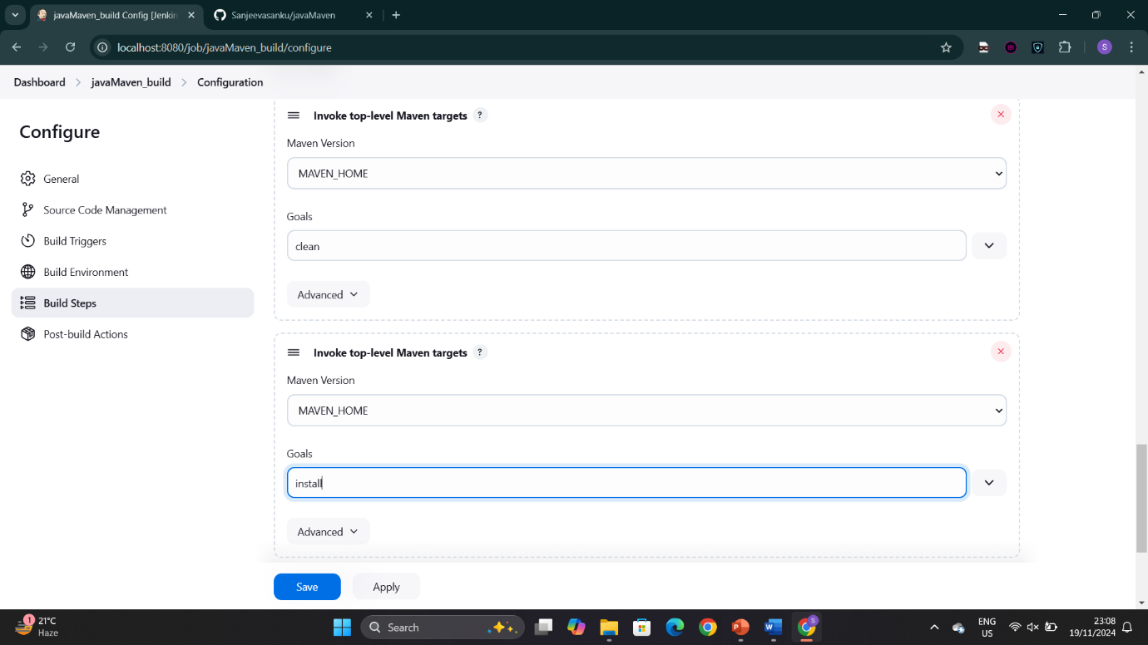

Select archive the artifacts in post build action

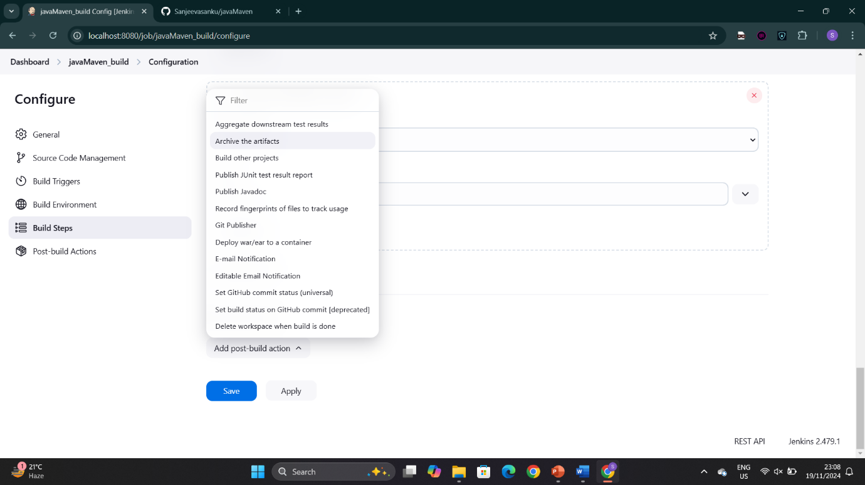

Mention **/* for archiving all the files

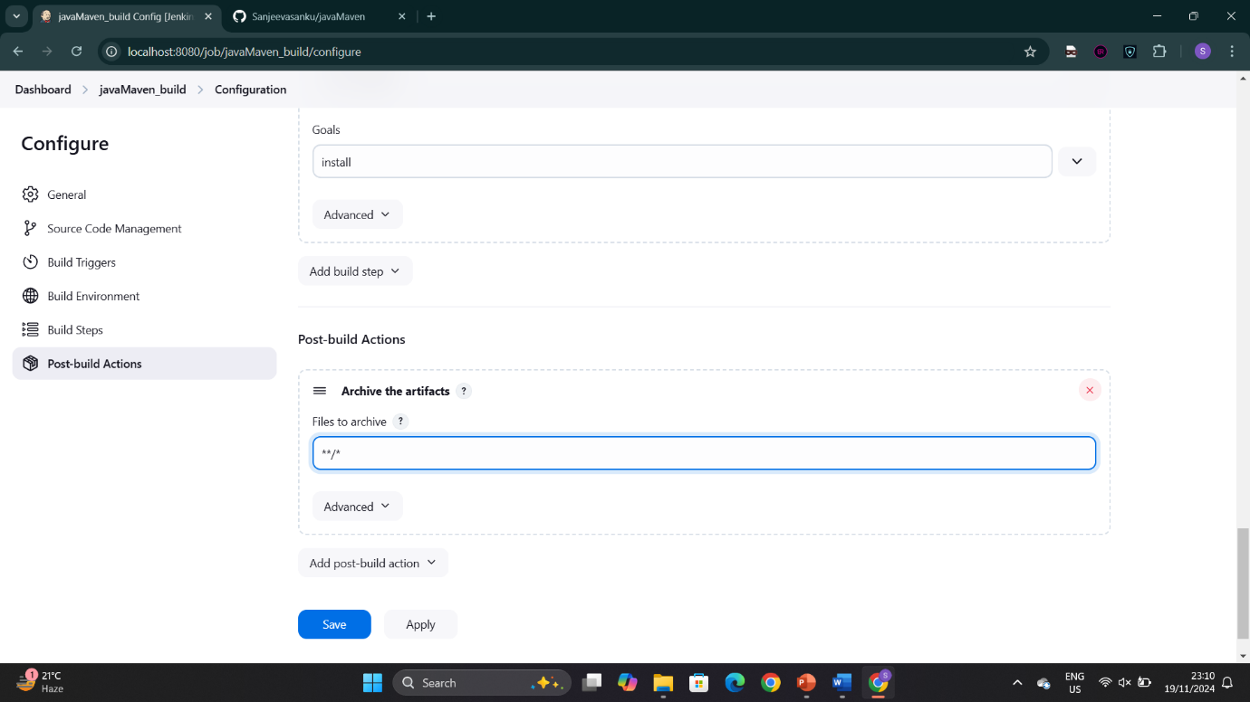

Select build other projects in post-build action

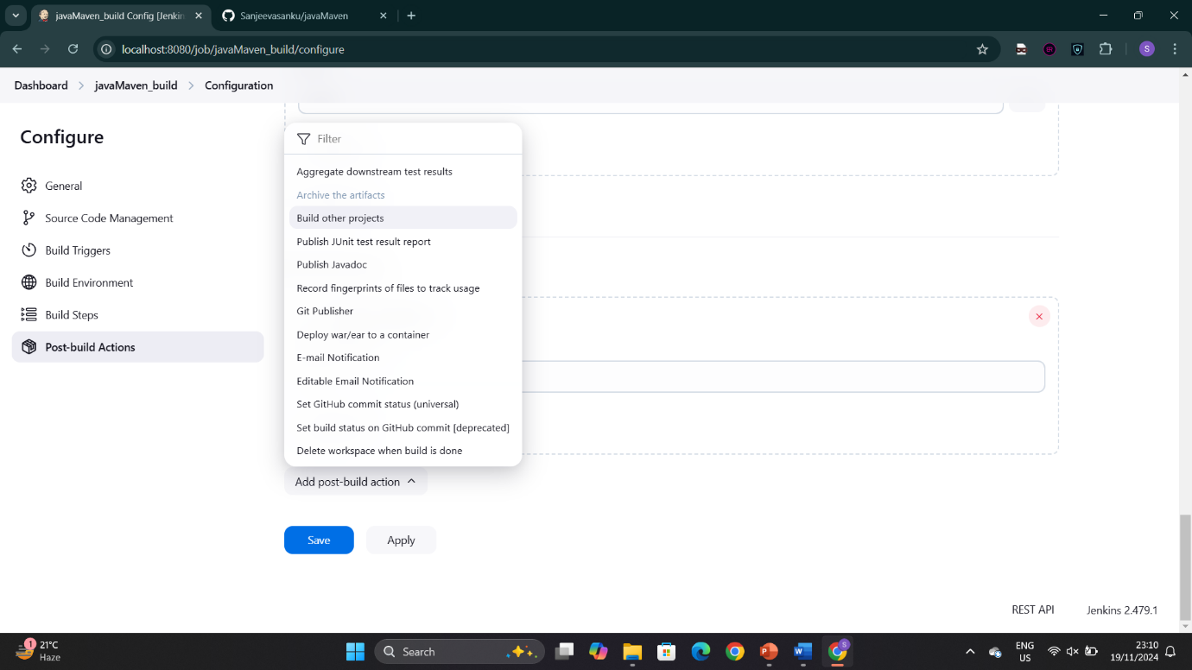

Select the test project

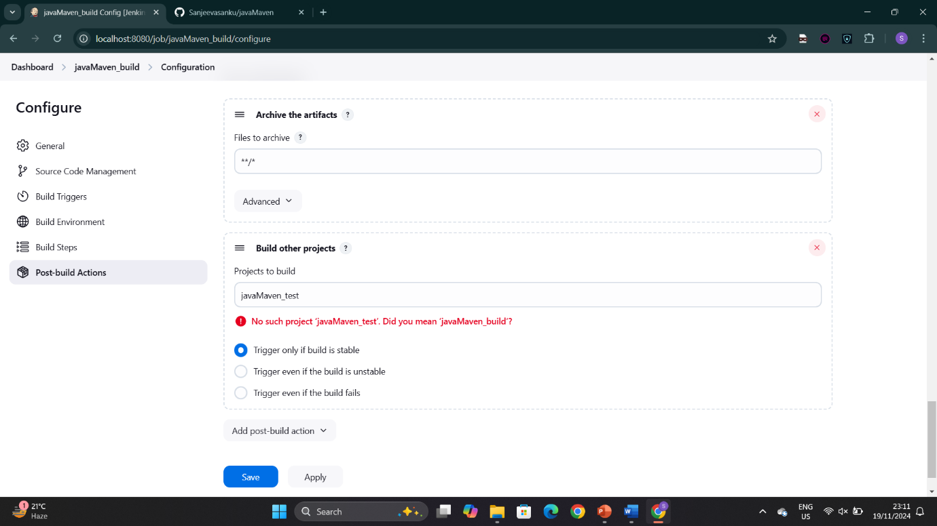

Create a new freestyle project for test

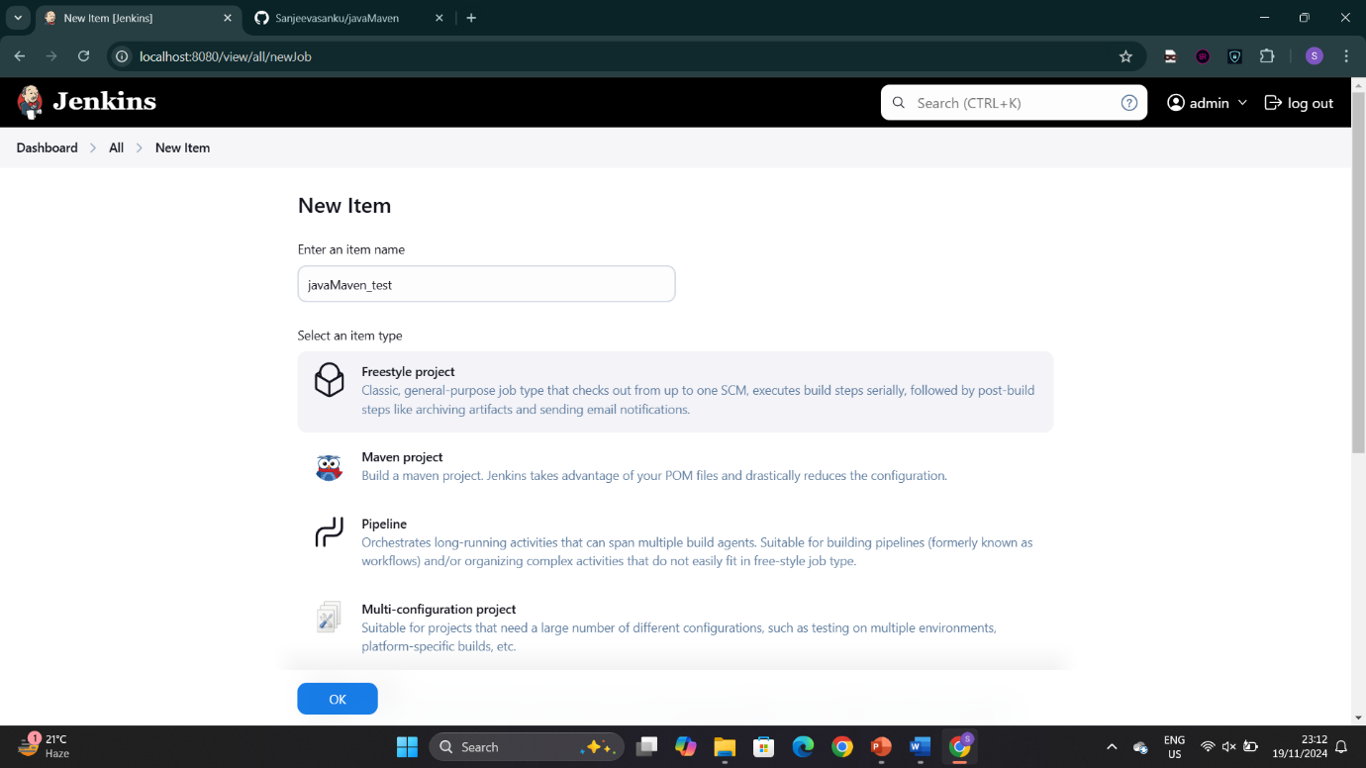

Select the option of delete workspace

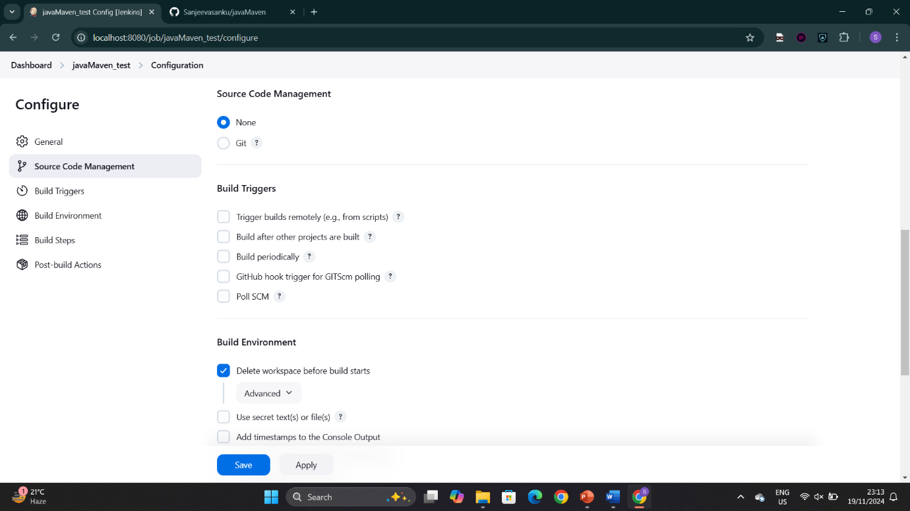

Select copy artifacts from another project in build step

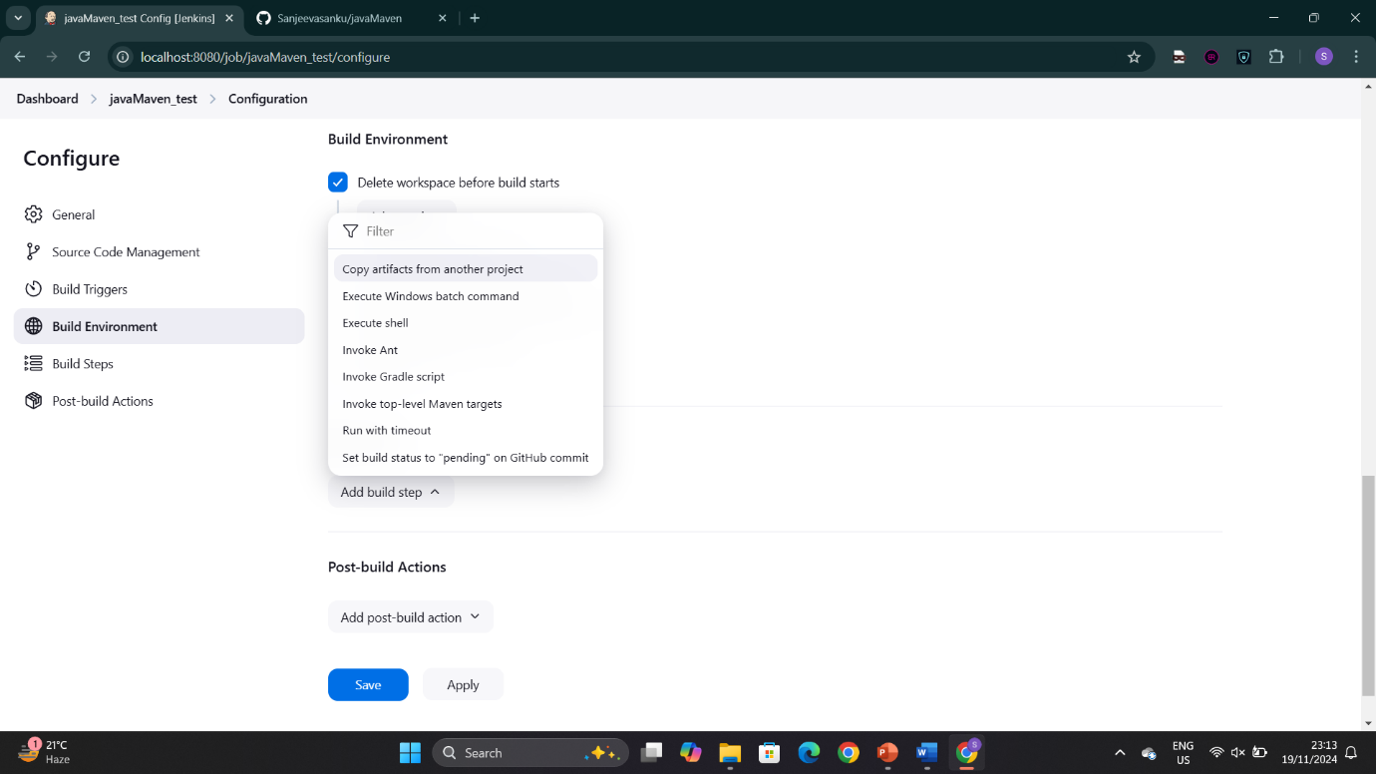

Mention **/* to copy all the files

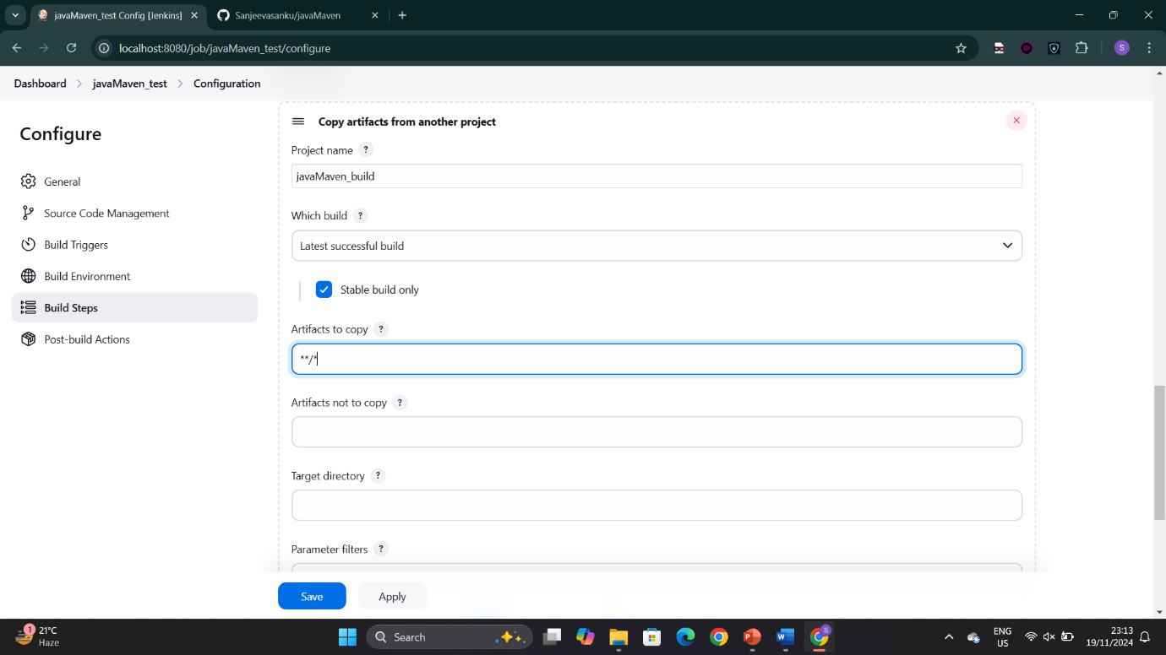

Mention the goal as test in invoke top-level maven targets

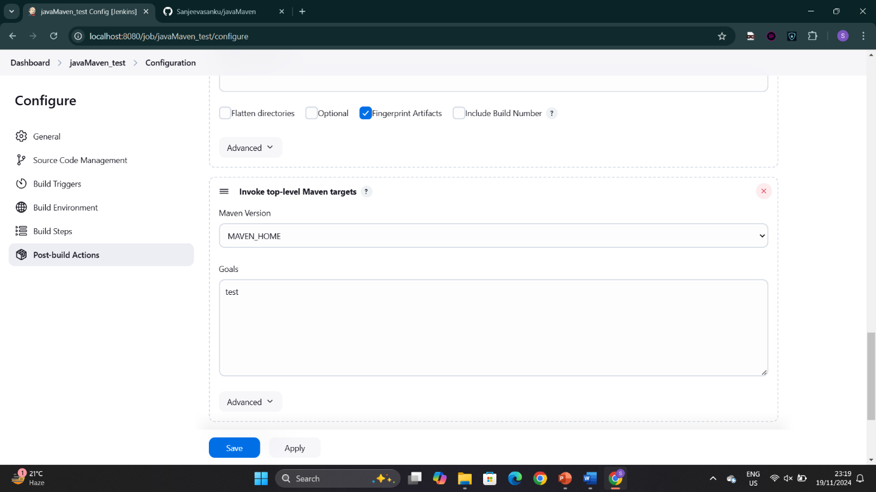

Select archive artifacts and mention **/* to archive all files

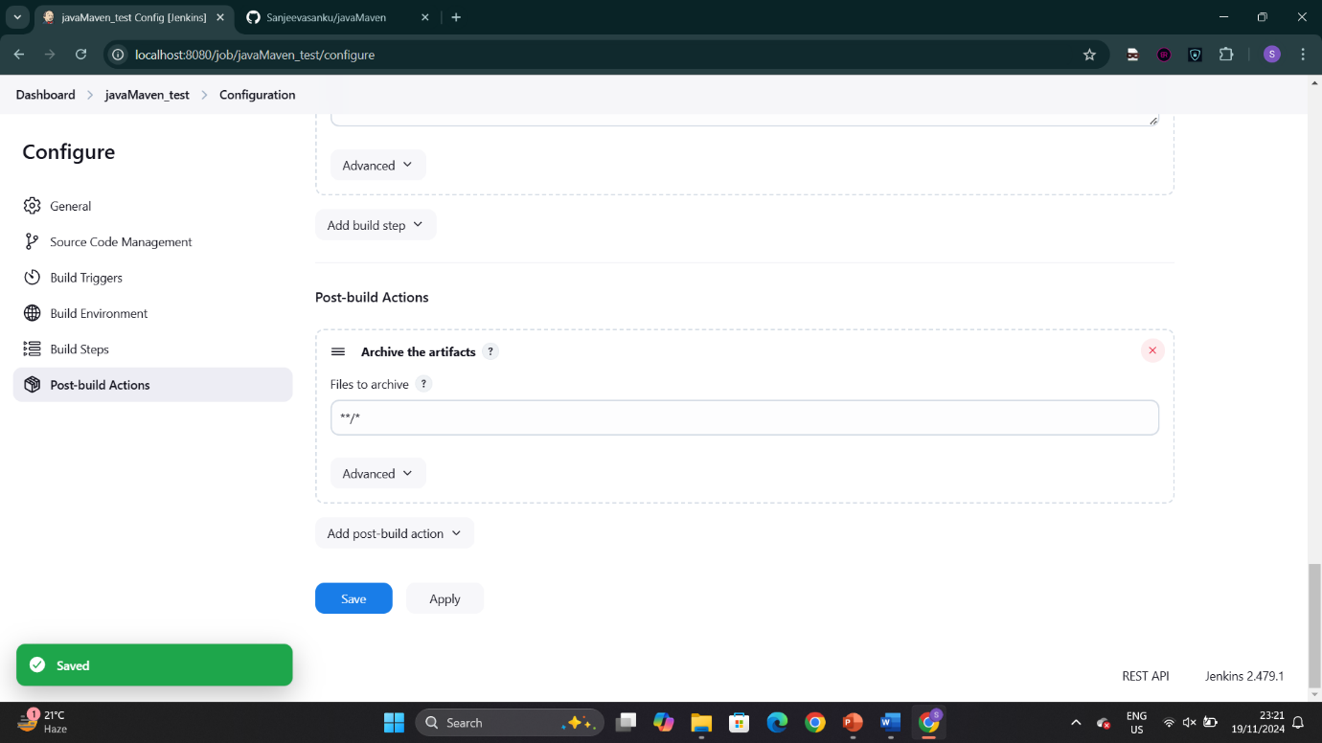

Click on new view

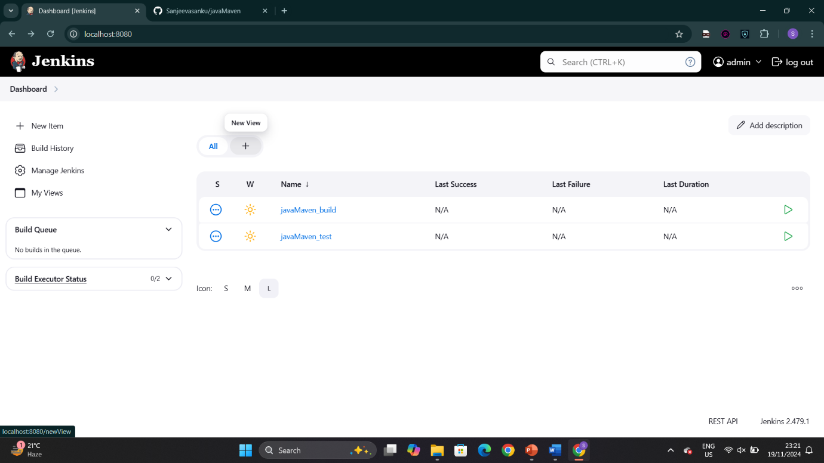

Create a build pipeline view

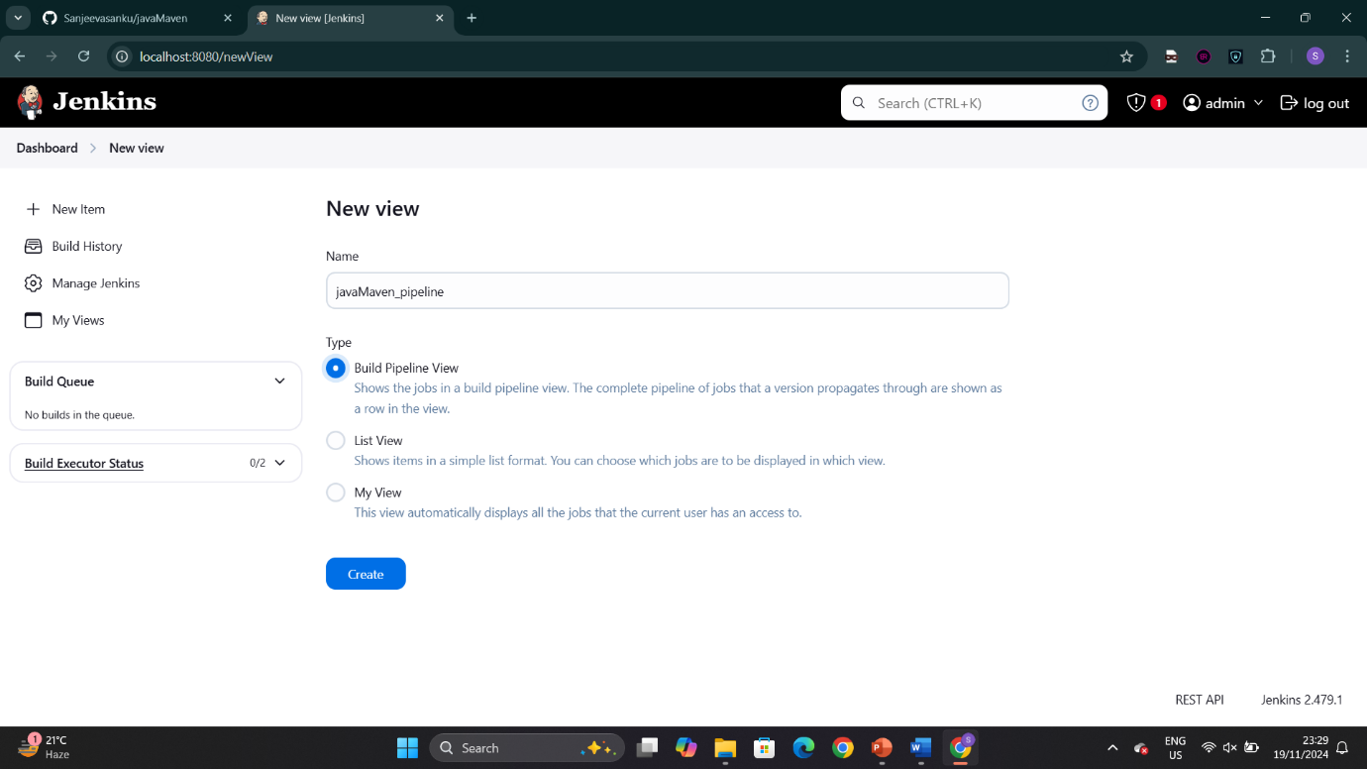

Select the initial job as javaMaven_build

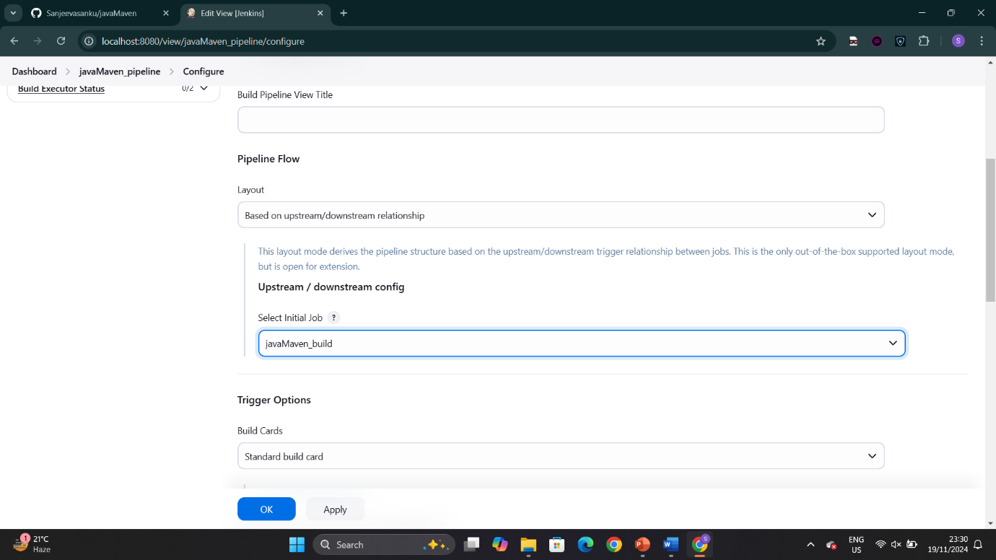

Click on apply and save

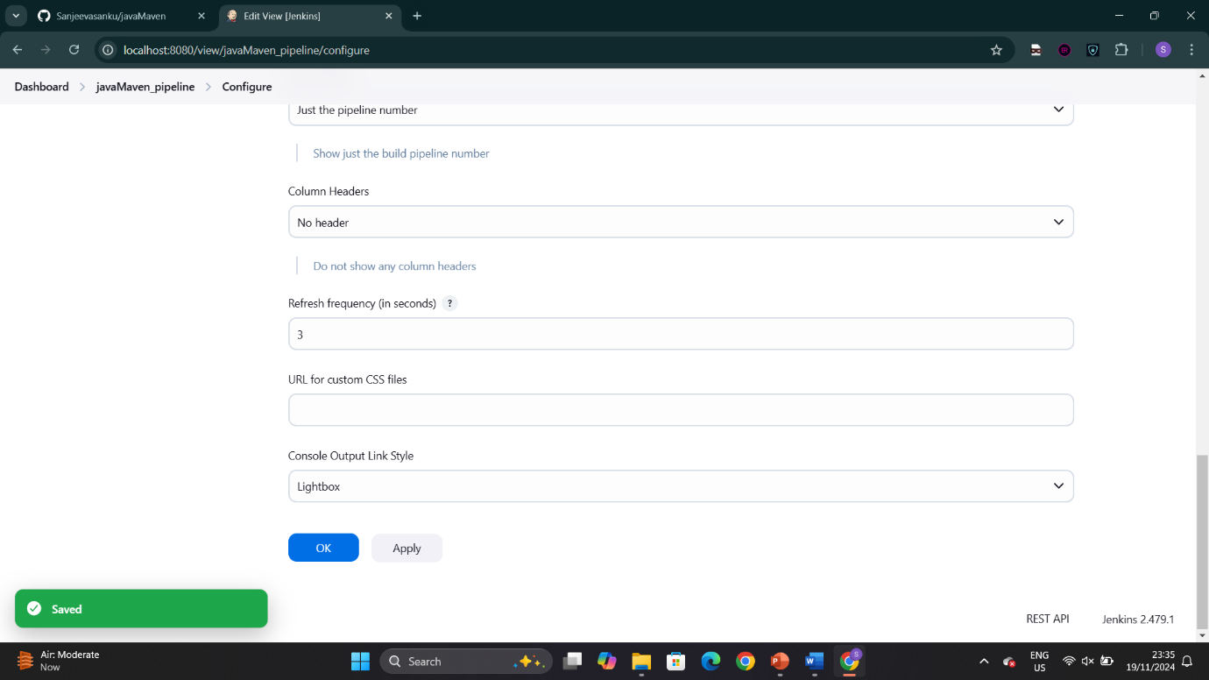

Now see the pipeline. Green indicates successful

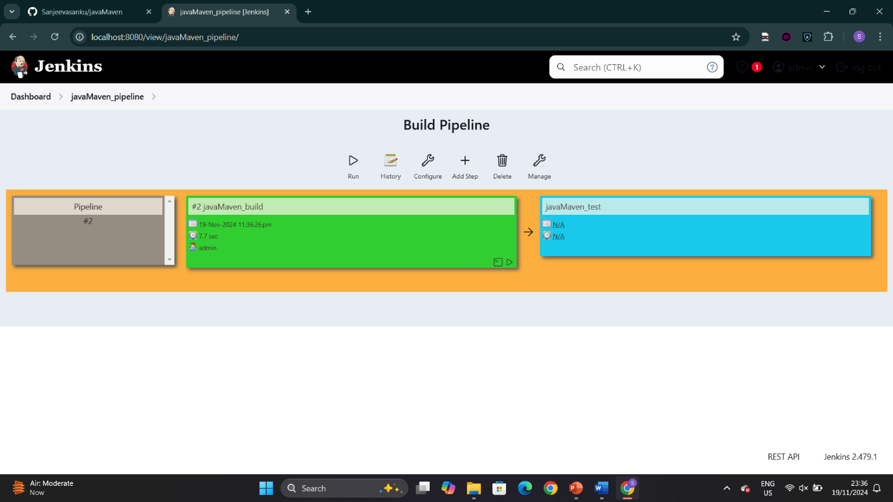

Check the console

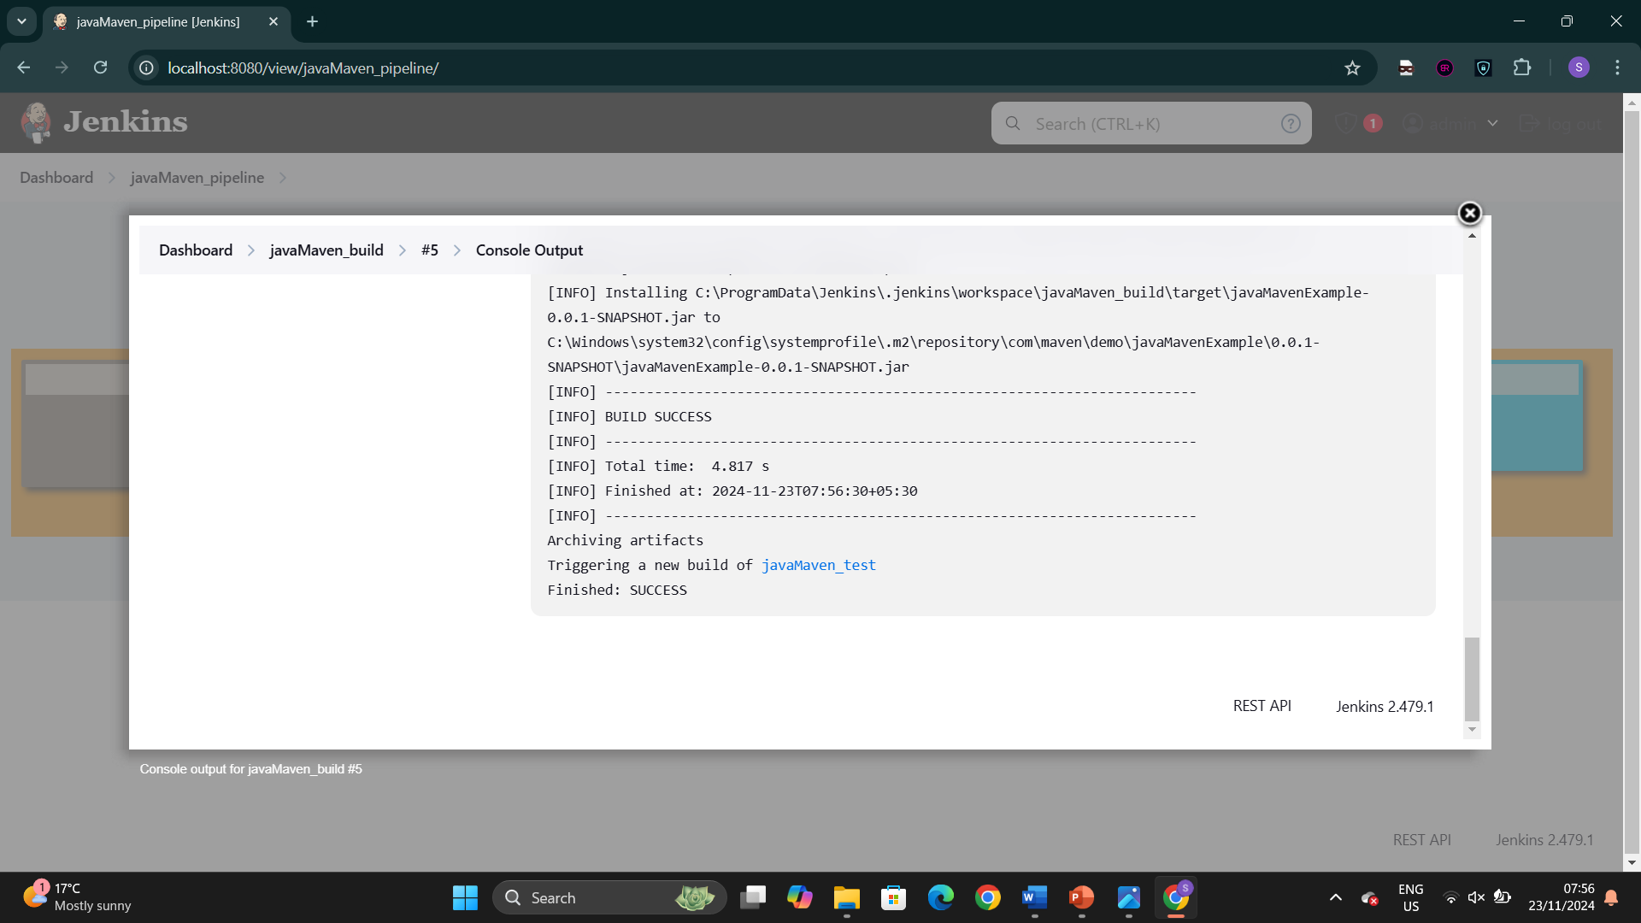

The build pipeline is successful

